**Stock Market Exchange Business**

1. **Stock Market Exchange Business –** Visitor Landing Page

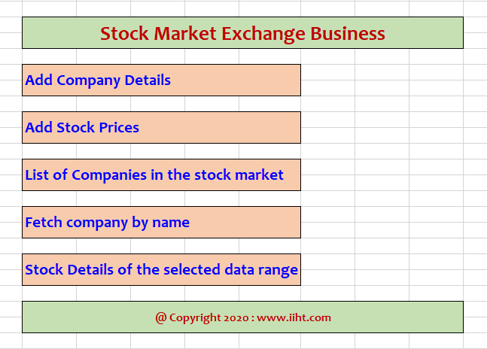

1. **SME : Register Company**

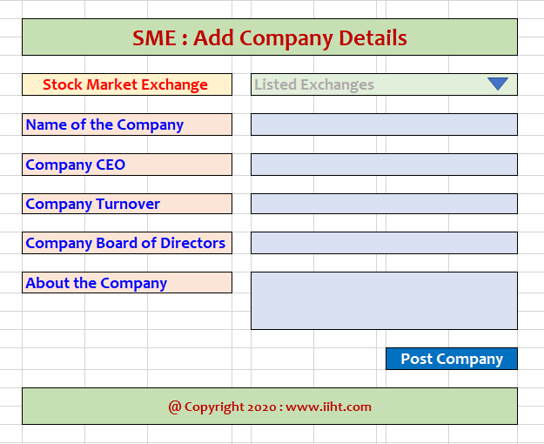

1. **SME : Assign Stock Price Details**

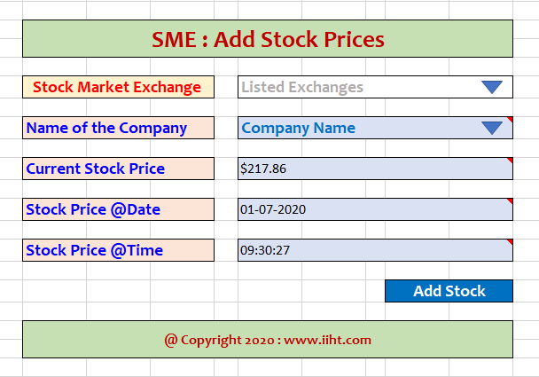

1. **SME : List of Companies**

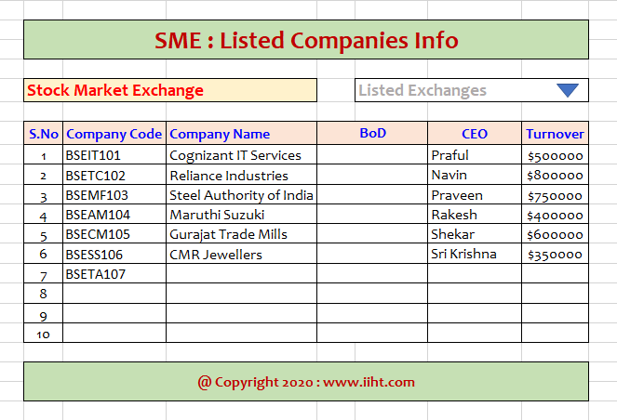

1. **SME : Company Stock Details**

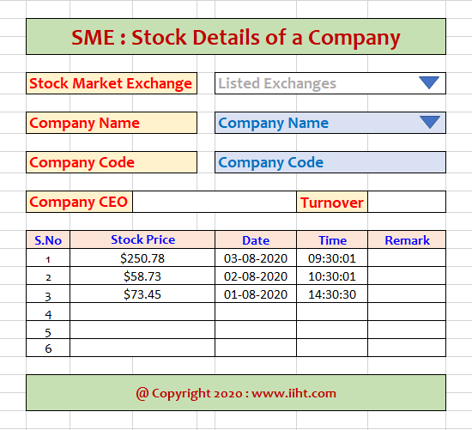

1. **SME : Company Stock Price Index**

